COFFEE SHOP ANALYSIS

Data Analysis project using Microsoft Excel



**Rinat Kalimullin**

27.12.23

# INTRODUCTION

I use Microsoft Excel in my first data analysis project to delve into the insightful world of coffee shops. This study summarizes my exploration and analysis of dummy data related to coffee shop customer reviews, revealing insights and proving hypotheses.

# HYPOTHESES

1. **More sales for popular coffee.** We can sell more coffee if we know what kinds of coffee people like.
2. **Advertisements for various age groups.** Perhaps younger people prefer Instagram advertisements, whereas older people prefer TV advertisements. We can place advertisements where they will be most effective in attracting new clients if we know this.
3. **Coffee discounts on "favorite" products.** People will return if we offer discounts on their favorite coffees.

# PROCEDURE

1. Downloading and uploading data
2. Removing duplicates
3. Handling missing information
4. Data formatting and validation

# DATA

| CUSTOMER INFO | PURCHASE INFO |
| --- | --- |
| Age | Favorite Coffee |
| Gender | Coffee Feedback |

# 

# RESULTS

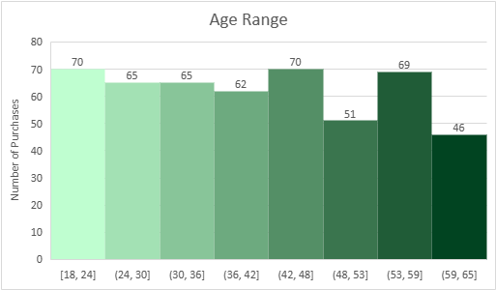

Insight:

1. The age distribution is fairly even across age groups, with peaks in the 18 to 24 and 42 to 48 age ranges.

Recommendation:

* Recognize the differences in age groups and tailor marketing strategies to each demographic's preferences and lifestyle.
* Consider age-specific promotions or offerings to cater to different age groups' varying tastes.

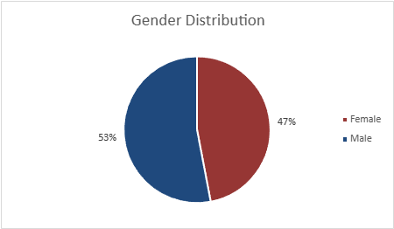

Insight:

1. Although males outnumber females in the customer base, both genders are well-represented.

Recommendation:

* Gender-specific strategies should be balanced with a holistic marketing approach that emphasizes inclusivity.
* Implement initiatives that celebrate diversity while also catering to a diverse range of customer preferences.

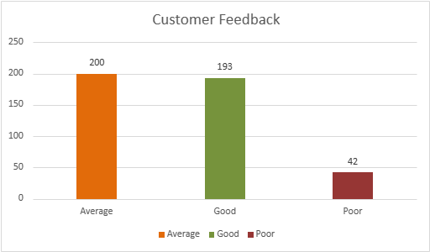

Insight:

1. The majority of customers provide average feedback, which is closely followed by positive feedback.
2. Poor feedback is the least common, but it is still notable.

Recommendation:

* Recognize and appreciate both average and positive feedback.
* Investigate the causes of negative feedback in order to address specific issues and improve customer satisfaction.

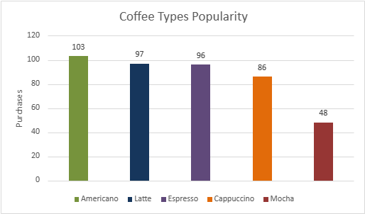

Insight:

1. The most popular option is the Americano, which is closely followed by the Latte and Espresso.
2. Cappuccino and Mocha have lower purchasing volumes.

Recommendation:

* To capitalize on their popularity, focus marketing efforts on promoting Americano, Latte, and Espresso.
* Consider targeted promotions or incentives to increase Cappuccino and Mocha sales.

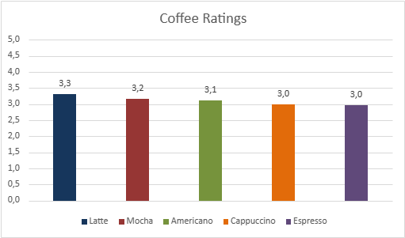

Insight:

1. Latte has the highest average rating, indicating that customers find it more satisfying in general.
2. Americano and Espresso are rated similarly, while Cappuccino and Mocha are rated slightly lower.

Recommendation:

* Use promotional materials to capitalize on the positive perception of Latte.
* Consider soliciting feedback and making improvements to address customer concerns about the lower-rated options (Cappuccino and Mocha).

**Correlation Between Purchase Volume and Coffee Ratings**

Insight:

1. Despite having the highest purchase volume, Americano has a slightly lower rating.
2. Latte has the highest rating and the highest purchase volume, indicating a positive correlation between popularity and customer satisfaction.
3. Despite having a lower purchase volume, Mocha has a higher rating.

Recommendation:

* Investigate ways to improve the Americano and Espresso experience to match their popularity.
* Continue to promote Latte because it is not only popular but also receives positive feedback.
* Investigate why Mocha has a higher rating despite a lower purchase volume, and consider strategies to increase sales.

# CONCLUSION

I investigated key aspects of a coffee shop's operations, such as popular coffee types, customer ratings, feedback, gender distribution, and age demographics, in this extensive data analysis project. The analysis yielded useful insights, such as the popularity of specific coffee types, the relationship between customer ratings and preferences, and the potential impact of gender and age on customer behavior. The recommendations provide actionable insights that can be used by the marketing team to tailor strategies, improve customer satisfaction, and capitalize on specific demographic preferences. A holistic and adaptive approach that takes into account both general trends and specific customer segments will be critical for the coffee shop's long-term success in a volatile and competitive market.